Diagrams

# Sequence Diagrams:

Create Customer Sequence Diagram:

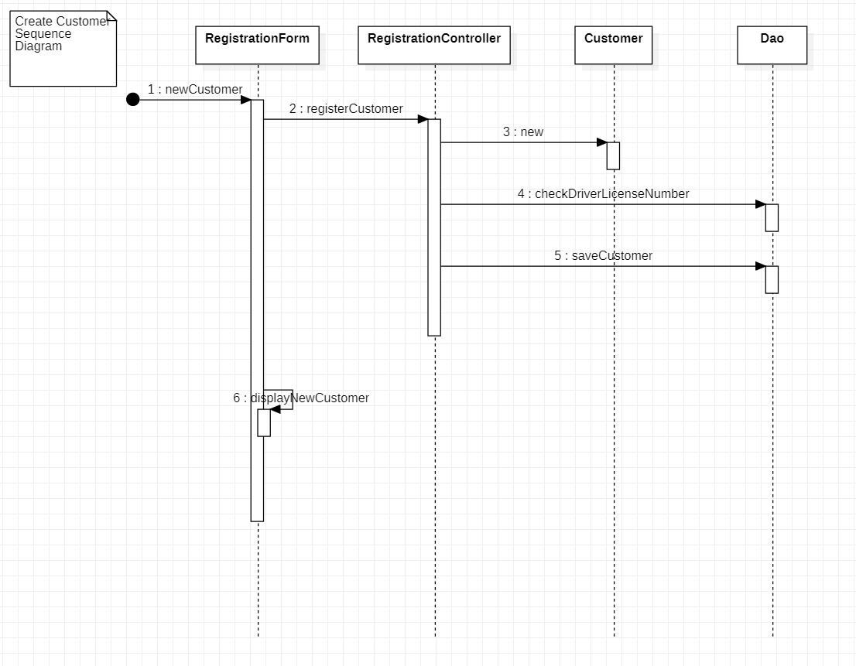

Create Car Sequence Diagram:

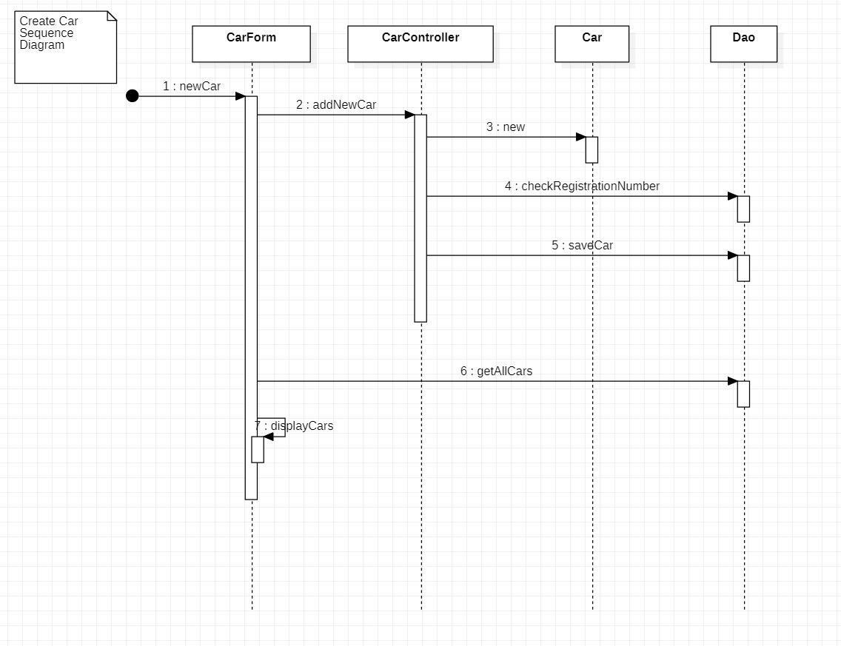

Search Cars Sequence Diagram

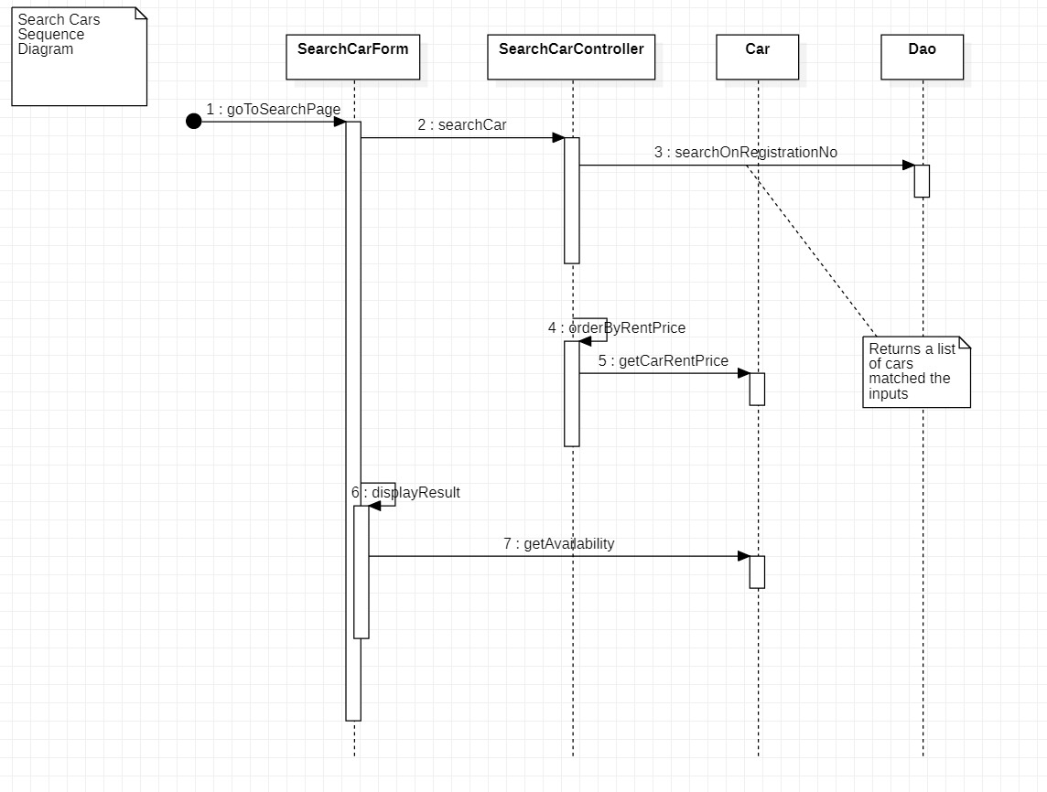

Rent Car Sequence Diagram

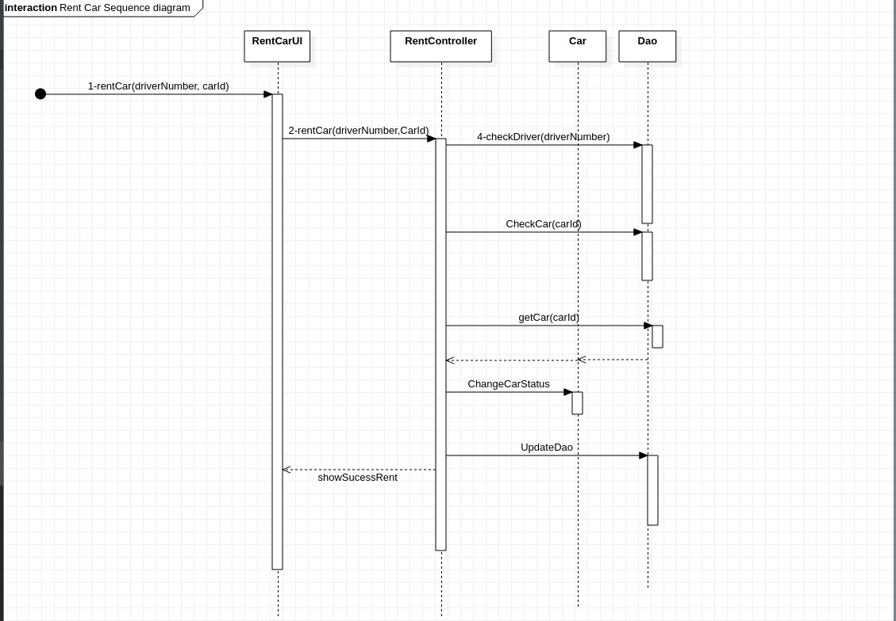

# Collaboration Diagrams:

Search Cars Collaboration Diagram

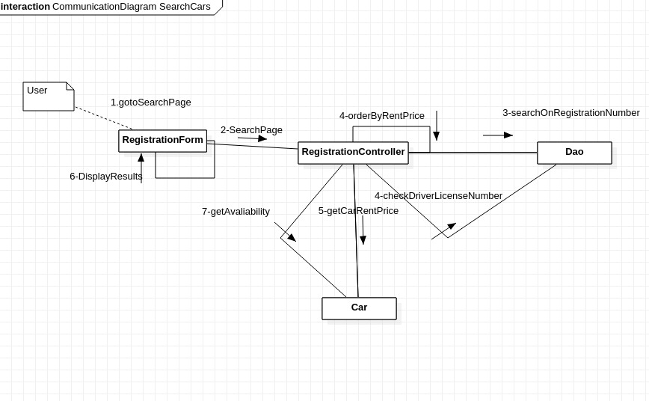

Create Customer Collaboration Diagram

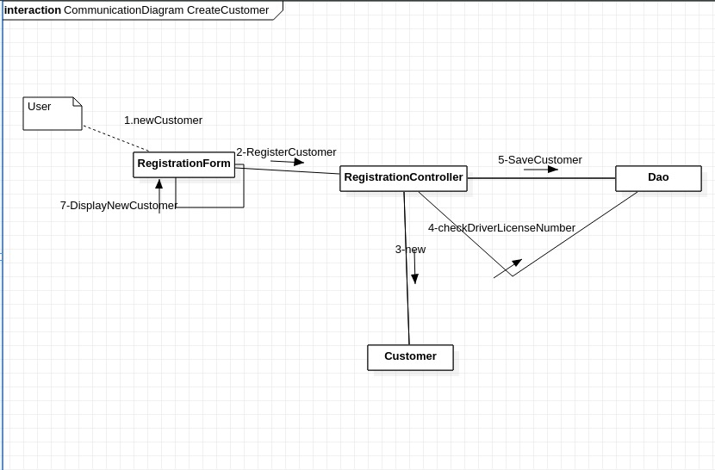

CreateCar Collaboration Diagram

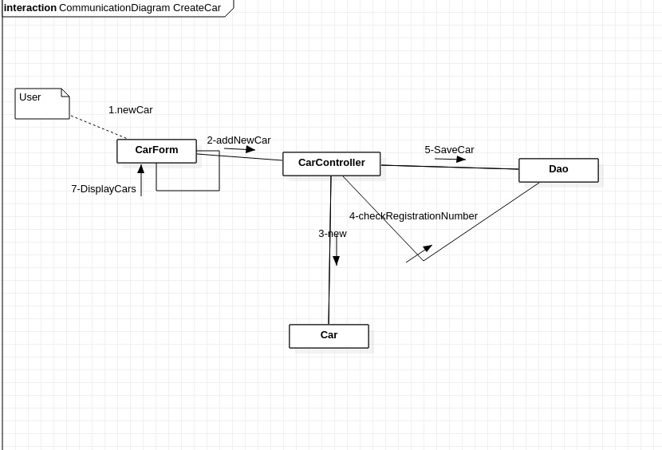

Car Rent Collaboration Diagram

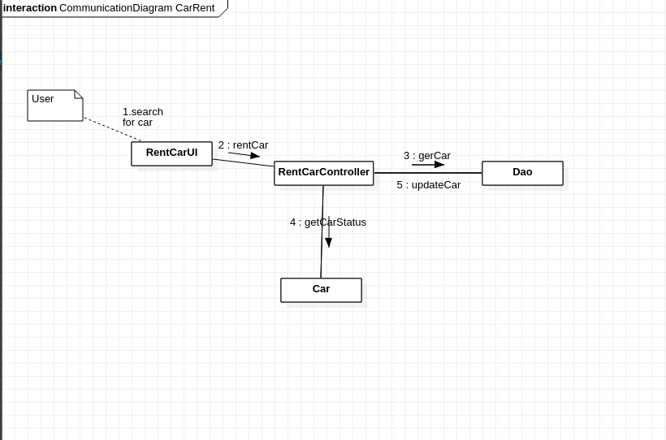

# VOPC

